**ASSIGNMENT 2**

|  |  |
| --- | --- |
| **PROJECT NAME** | **CUSTOMER CARE REGISTRY** |
| **NAME** | **V.Balaji** |
| **ROLL NO** | **4211191031009** |
| **TEAM ID** | **PNT2022TMID10739** |

**PROGRAM 1:**

form>

<table>

<tr>

<td>

<label for="uname">Name</label>

</td>

<td>

<input type="text" id="uname" name="username">

</td>

</tr>

<tr>

<td>

<label for="uemail">Email</label>

</td>

<td>

<input type="text" id="uemail" name="usermail">

<button type="button">Check</button>

</td>

</tr>

<tr>

<td>

<label for="age">Age</label>

</td>

<td>

<input type="text" name="userage" id="age" size="2"maxlength="2">

</td>

</tr>

<tr>

<td>

<label>Country</label>

</td>

<td>

<input type="text" value="India" name="country" disabled>

</td>

</tr>

<tr>

<td>

<label for="pass">Password</label>

</td>

<td>

<input type="password" id="pass">

</td>

</tr>

<tr>

<td>

<label for="res">Resume</label>

</td>

<td>

<input type="file" id="res">

</td>

</tr>

<tr>

<td>

<label>Hobbies</label>

</td>

<td>

<label>

<input type="checkbox" checked> Cricket

</label>

<label>

<input type="checkbox"> Football

</label>

</td>

</tr>

<tr>

<td>

<label>Gender</label>

</td>

<td>

<label>

<input type="radio" value="f" name="gender"> Female</label>

<label>

<input value="m" type="radio" name="gender"> Male</label>

</td>

</tr>

<tr>

<td>

<label for="city">City</label>

</td>

<td>

<select id="city" name="city">

<option disabled selected>--Choose City--</option>

<optgroup label="Metros">

<option>New Delhi</option>

<option>Mumbai</option>

<option>Chennai</option>

<option>Kolkata</option>

</optgroup>

<optgroup label="Others">

<option>Noida</option>

<option>Gurgram</option>

<option>Faridabad</option>

<option>Gaziabad</option>

</optgroup>

</select>

</td>

</tr>

<tr>

<td>

<label>Address</label>

</td>

<td>

<textarea rows="4" cols="40"></textarea>

</td>

</tr>

<tr>

<td></td>

<td>

<input type="submit" value="Submit">

<input type="reset">

</td>

</tr>

</table>

</form>

**OUTPUT:**

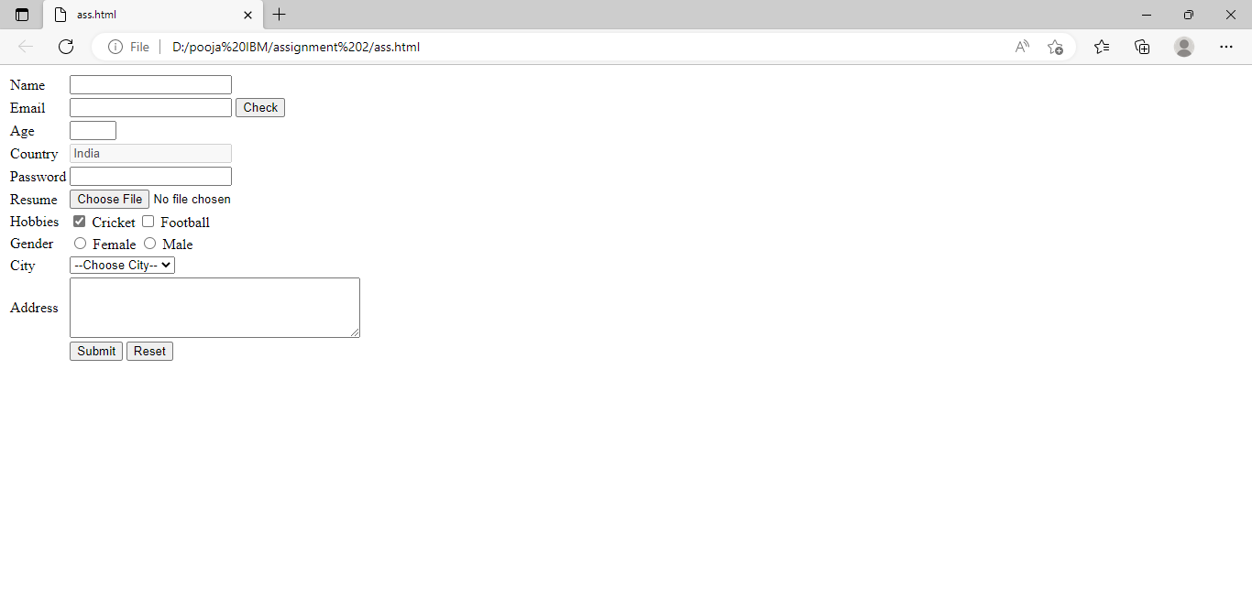

**PROGRAM 2:**

<html>

<head><link href="style.css" rel="stylesheet">

</head>

<title>WCC</title>

</body>

<h2>BALAJI V,BALAJI R,KRISHNARAJ K,BALAKUMARAN R.</h2>

</body>

</html>

h2{color:red;}

**OUTPUT:**

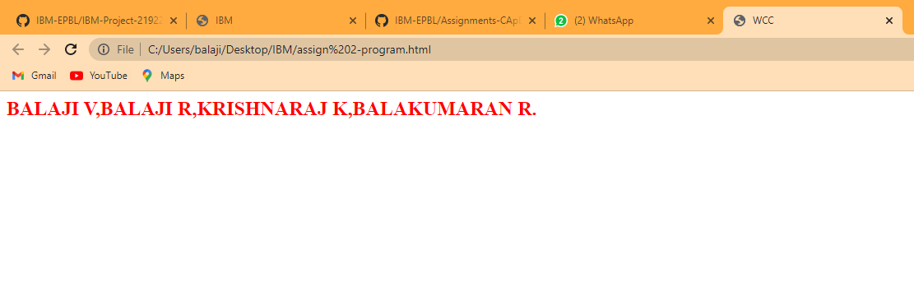

**PROGRAM 3:**

from flask import Flask

app = Flask(__name__)

@app.route("/team")

def course():

return"""

<h1>TEAM MEMBER</h1>

<table border='1'>

<caption> TEAM DETIALS </caption>

<thead>

<th>First Name</th>

<th>Last Name</th>

</thead>

<tr>

<td>balaji</td>

<td>V</td>

</tr>

<tr>

<td>balakumaran</td>

<td>R</td>

</tr>

<tr>

<td>balaji </td>

<td>R</td>

</tr>

<tr>

<td>Krishnaraj</td>

<td>K</td>

</tr>

<tr>

</table>"""

if __name__ == "__main__":

app.run(debug=True)

**OUTPUT:**

